Registration for the II Nobel Fest is now open

II Central Asia Nobel Fest on technology and innovation will be held in online format between April 7-9, 2021. Titled “Inventing the Future”, it is dedicated to Day of Science in Kazakhstan and will feature a flagship Lecture Series with Nobel Laureates and world-renowned scientists that will take place in Kazakhstan’s universities from April 12 to 16, 2021.

Registered participants will get unlimited access to lectures, seminars and interactive discussions with Nobel Laureates, heads of tech corporations and world-renowned scientists. Nobel Prize winners in Physics, Takaaki Kajita and John Mather; Nobel Prize winners in Chemistry, Aaron Ciechanover and Jean-Marie Lehn; Nobel Prize winner in Economic Sciences Michael Spence, as well as 9 Breakthrough Prize winners have already confirmed their participation in the Central Asia Nobel Fest.

The registration is free of charge and available on the event’s official website; the number of places is limited, so it is best to register early.

Thinking about the future, it is apparent that technologies will change absolutely every aspect of life. How will developments and breakthroughs in technologies like 5G and AI affect daily life? What is the future of education? Which skills will be most in demand in the post-pandemic world? And is it possible for technologies to bridge the inequality gap? These and other questions of interest will be discussed during II Nobel Fest by the following industry experts and professors who already confirmed their participation:

In the field of education

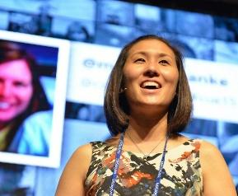
Jennie Magiera, Global Head of Education Impact at Google

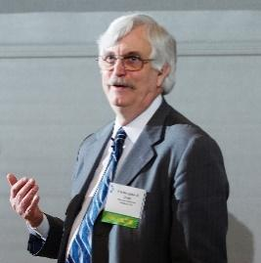

Christopher Dede, Professor at Harvard Graduate School in Education

Andreas Schleicher, Director for Education and Skills, Organization for Economic Co-operation and Development (OECD), Co-Founder of PISA

In the field of technology and innovation
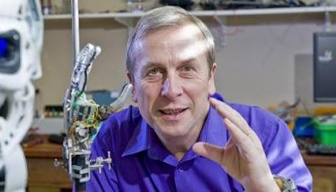
Kevin WARWICK, world-renowned cybernetics scientist, Visiting Professor at the University of Reading

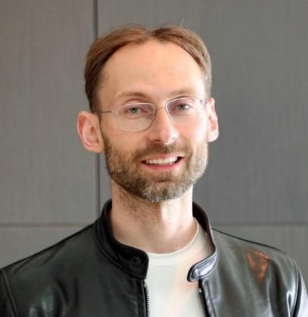

Michael Bronstein, Head of Graph Machine Learning at Twitter and Professor at Imperial College London

Sheryl Connelly, Manager of Global Trends & Futuring at Ford Motor Company

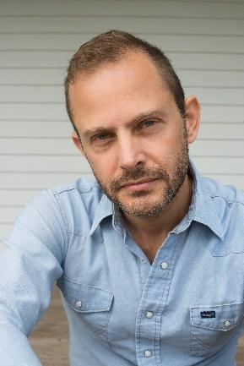
Gideon Lichfield, Editor-in-chief, MIT Technology Review

And in the field of economics:
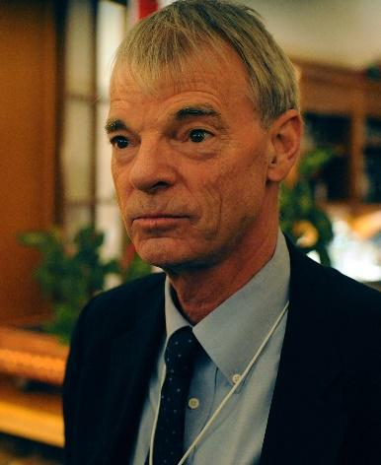
Michael Spence, Winner of 2001 Nobel Prize in Economic Sciences

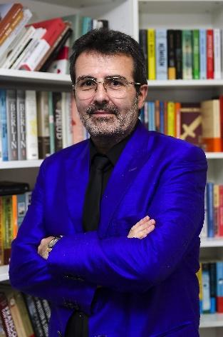

Xavier Sala-i-Martin, economist, professor at Columbia University

And dozens of other renowned scientists and experts.

The official partners of the Central Asia Nobel Fest: Chevron Corporation, Auezov South Kazakhstan University, Astana Medical University, BTS Education and BTS Digital, AIFC Bureau for Continuing Professional Development, and law firm "Redbrick". Zhubanov University is acting as an Intellectual Partner. Ministry of Education and Science of the Republic of Kazakhstan and JSC "Science Fund" have also supported the event.

General media partners: The Steppe, Forbes Kazakhstan, JSC "Khabar Agency".

Join our event for free at https://nobel-fest.inpolicy.net/
Follow II Nobel Fest’s official Instagram page for updated news and content.

